**Promoting a Cult, for the "Good" of Society**

Another fifth generation warfare tool of governments, propagandists and intelligence agencies

[](https://substack.com/profile/49176289-robert-w-malone-md-ms)

[ROBERT W MALONE MD, MS](https://substack.com/@rwmalonemd)

SEP 18, 2023

63

[6](https://rwmalonemd.substack.com/p/promoting-a-cult-for-the-good-of/comments)

3

[Share](javascript:void(0))

[[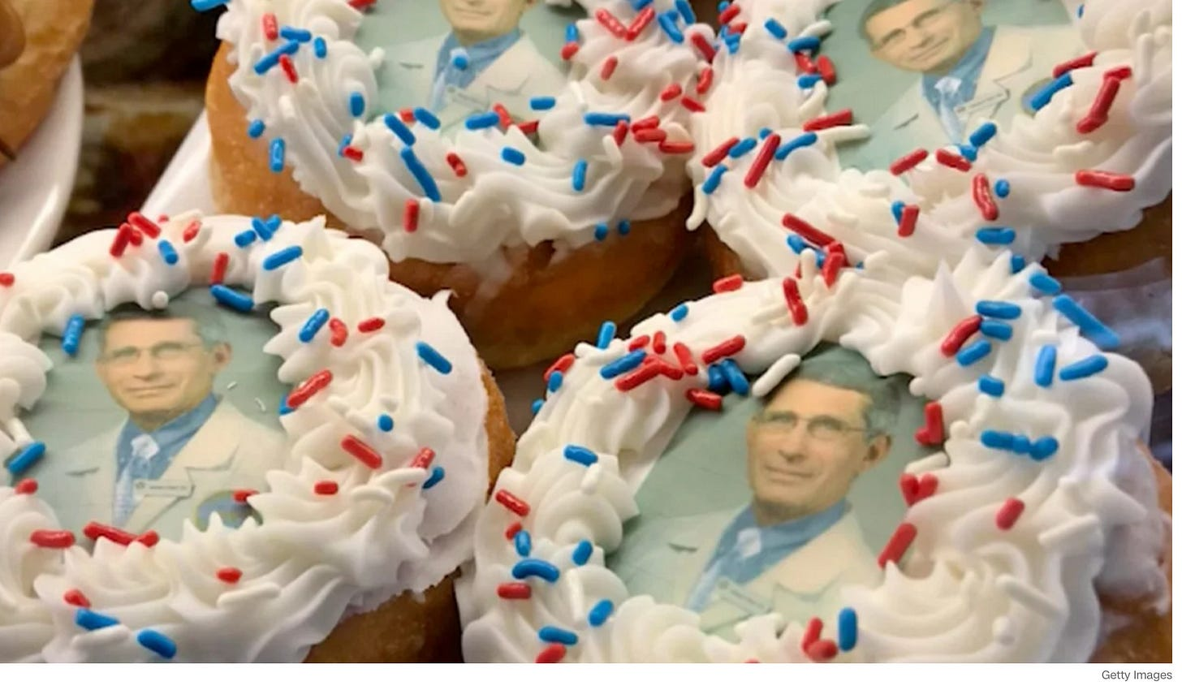](https://substackcdn.com/image/fetch/f_auto,q_auto:good,fl_progressive:steep/https:/substack-post-media.s3.amazonaws.com/public/images/796553c5-266c-4069-98b4-1f6396831726_2060x1202.png)](https://substackcdn.com/image/fetch/f_auto,q_auto:good,fl_progressive:steep/https%3A%2F%2Fsubstack-post-media.s3.amazonaws.com%2Fpublic%2Fimages%2F796553c5-266c-4069-98b4-1f6396831726_2060x1202.png" \t "_blank)

The **Netflix documentary “How to Become a Cult Leader”** is a must watch, if like me, you are still mystified as to how our society, which become so hysterical over COVID-19, then managed to pivot 180 degrees to becoming just as hysterical about climate change *science <insert sarcasm emoji>* and the *science <insert sarcasm emoji>* of gender ideology. You know, that new *scientific* definition of gender - as defined by the World Health Organization. Because we all know the WHO is the global arbiter of *health truthiness*.

[[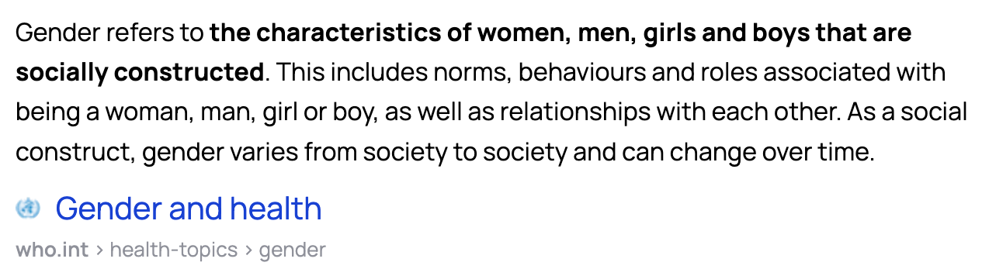](https://substackcdn.com/image/fetch/f_auto,q_auto:good,fl_progressive:steep/https:/substack-post-media.s3.amazonaws.com/public/images/cf6a2306-e09d-4066-8593-a6c361378c39_1274x356.png)](https://substackcdn.com/image/fetch/f_auto,q_auto:good,fl_progressive:steep/https%3A%2F%2Fsubstack-post-media.s3.amazonaws.com%2Fpublic%2Fimages%2Fcf6a2306-e09d-4066-8593-a6c361378c39_1274x356.png" \t "_blank)

Over the past two years, I have come to realize just how easily groups of people can be manipulated and controlled by those in power. That the processes used for such manipulation reflect the same processes used by cult leaders.

The official trailer from the documentary describes why people join cults, but it also offers insights into exactly how people can be manipulated.

**Cult-like Behavior**

In 2021, I **[**[ROBERT W MALONE MD, MS](https://substack.com/@rwmalonemd)**]** edited Robert F. Kennedy’s book “The Real Anthony Fauci”. It was a huge undertaking. I was

1. proud of my contributions but also
2. horrified by what that book revealed, as was Jill.

She posted a link to the book on her facebook page - just a link mind you, with a recommendation to read the book. An in-law of ours who lives in the DC area, someone we thought of as a personal friend, immediately blocked Jill permanently. The sin being that Jill was being critical of Anthony Fauci by **publicizing RFKjr’s carefully researched and footnoted book**. This branch of our family has literally not talked to Jill or I since. We are not invited to gatherings where they are in attendance. We are permanently banned from the “village” for the social sin of posting a link that that was critical of Anthony Fauci.

**This is one example cult-like behavior.** I suspect that you are familiar with many others.

[[](https://substackcdn.com/image/fetch/f_auto,q_auto:good,fl_progressive:steep/https:/substack-post-media.s3.amazonaws.com/public/images/68797467-3b6d-4c85-9c99-a890632be9e0_606x558.png)](https://substackcdn.com/image/fetch/f_auto,q_auto:good,fl_progressive:steep/https%3A%2F%2Fsubstack-post-media.s3.amazonaws.com%2Fpublic%2Fimages%2F68797467-3b6d-4c85-9c99-a890632be9e0_606x558.png" \t "_blank)

It was at that moment when I really began to realize that what was happening with the COVID-19 propaganda and how it was affecting people was more than just a misunderstanding or absence of facts. After listening to Dr. matthias desmond’s brilliant lecture in 2021 on mass formation - I began to formulate the idea that this was a much deeper issue that had underlying roots in [totalitarian movements](https://www.amazon.com/origins-totalitarianism-Hannah-Arendt/dp/1179832442/?_encoding=UTF8&pd_rd_w=rc61Q&content-id=amzn1.sym.579192ca-1482-4409-abe7-9e14f17ac827&pf_rd_p=579192ca-1482-4409-abe7-9e14f17ac827&pf_rd_r=131-1577862-6902533&pd_rd_wg=egTiH&pd_rd_r=884eb4e4-58b7-46ea-8655-a21cb1d62cf6&ref_=aufs_ap_sc_dsk), as the holocaust survivor Hannah Arendt had laid out so clearly long ago.

My thinking has evolved on this topic. **Yes, mass formation (groups) and mass psychosis - and I do mean psychosis, because I am writing of the individual, is a real phenomenon. Despite the fact that it is not listed in the American “Diagnostics and Statistics Manual”, many psychiatrists, psychologists and (even public leaders such as the late Robert McNamara) recognize this disorder.**

I personally believe that the US government, the “five eyes” intelligence community and many world leaders have come to understand the power of cults, as well as the power of the mass formation process, and have learned to harness these psychosocial processes for their own purposes through neurolinguistic programming and other methods. They now use that power to manipulate the masses for their own purposes, as evidenced by the over 6,000 peer reviewed academic publications available on pubmed concerning vaccine hesitancy and studies on how to overcome it. [1260 of those papers can be found here](https://maloneinstitute.org/general-1).

But what exactly is a cult? The standard definition is this:

[[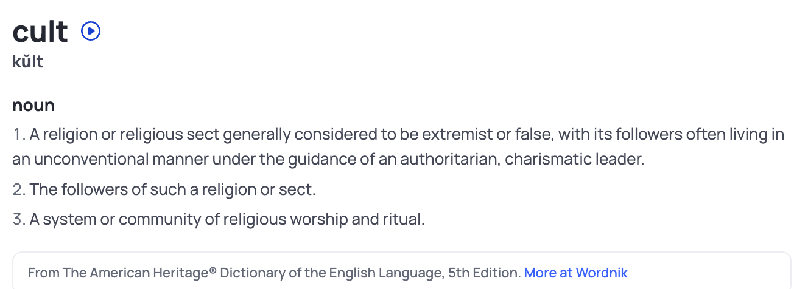](https://substackcdn.com/image/fetch/f_auto,q_auto:good,fl_progressive:steep/https:/substack-post-media.s3.amazonaws.com/public/images/3a6d256d-55a1-4907-adc3-415fa1f47709_1304x476.png)](https://substackcdn.com/image/fetch/f_auto,q_auto:good,fl_progressive:steep/https%3A%2F%2Fsubstack-post-media.s3.amazonaws.com%2Fpublic%2Fimages%2F3a6d256d-55a1-4907-adc3-415fa1f47709_1304x476.png" \t "_blank)

But then in order to understand the definition of a cult, one must ask what is, and what is not a religion?

*“*[*Religion is a set of organized beliefs*](https://www.verywellmind.com/religion-improves-health-2224007)*, practices, and systems that most often relate to the belief and****worship of a controlling force****, such as a personal god or another supernatural being.*

*Religion often involves cultural beliefs, worldviews, texts, prophecies, revelations, and morals that have spiritual meaning to members of the particular faith, and it can encompass a range of practices, including sermons, rituals, prayer, meditation, holy places, symbols, trances, and feasts.”*

The above definition of a religion makes the definition of a cult problematic. If a cult is just a religion that is false or extreme, who is to judge that? Don’t most religions profess to offer truth above and beyond other religions? Don’t most religious sects strive to produce charismatic leaders who can inspire? What about God, isn’t God the ultimate “*authoritarian*” leader?

Our government has come to push **the cult of scientism**, as if that were the only answer to our social and technical challenges - as if science is a religion.

At the heart of the definition of scientism, is the theory of materialism. [Materialism](https://www.wordnik.com/words/materialism) is the idea that the only reality is physical matter. That physical matter is the *controlling force* to understanding the world. It something can’t be measured, it isn’t real. Scientism holds that there can be no supernatural, no religion, no God - everything must be grounded in physical matter. That physical matter is the *controlling force*. That which we can not see, does not exist. At the heart of religion is belief or faith. Scientism rejects this- the existence of an unseen and unmeasurable entity or force which influences our lives cannot be an acceptable answer or even a hypothetical answer for a believer in scientism. Because Scientism is their religion, the *controlling force* is physical matter.

According to[J P. Moreland](https://en.wikipedia.org/wiki/J._P._Moreland), scientism is “the view that the hard sciences alone have the intellectual authority to give us knowledge of religion.” Yet so much of what science studies or believes is unknown and unknowable. The infinite universe comes to mind. In fact, one could argue that at the heart of physical sciences is the expanding universe, which is essentially a controlling force of the physical sciences. Does that also make astrophysics a religion?

Our government was set-up by charter (the Constitution) to be independent from any one religion. However, in the current era, government has completely embraced scientism, as evidenced by what is taught in our school textbooks. So by dogmatically teaching only the tenets of scientism, is our government teaching a new form of religion, a [false religion](https://en.wikipedia.org/wiki/Four_Horsemen_of_the_Apocalypse)? And if “scientism” is the current leading false religion, what of transhumanism? The writings and mutterings of WEF leader (and top advisor to Klaus Schwab) Professor Yuval Harari (such as “[Homo Deus](https://www.amazon.com/Homo-Deus-Brief-History-Tomorrow/dp/0062464310)” - man god) certainly indicate that to be the case.

Scientism holds that there can be no supernatural, no religion, no God - **everything must be grounded in physical matter.** **That which we can not see, does not exist (except for that expanding universe - which needs to be taken on faith).** The problem with this being promulgated as a scientific theory is that it has ***not*** been repeatedly tested and validated. Basically, the thesis here is that if we do not have senses or technologies which can detect something, then it does not exist. But the truth is that observable measurable physical matter as the only way to describe this entire planet, universe and our individual consciousness has absolutely NOT been repeatedly tested and validated. We can’t readily measure what we don’t know exists. And our senses have been selected to only detect those phenomenon, those environmental data, which are most useful (adaptive) for us to be able to detect. One small example to illustrate the point is our relative human blindness to ultraviolet spectrum light which is readily detected by many other species (“bee purple”, for example).

This all loops back around to what is a cult, and why cults are important.

**Cult followers and leaders**

A cult leader and his/her followers are bound together by shared beliefs, practices, and rituals that are considered extreme or even deviant, as judged by mainstream belief systems.

Cult followers tend to have the following characteristics:

* **have less spiritual or religious upbringing**
* **Young adults searching for their own personal identity**
* **need for companionship**
* **Loneliness and isolation**
* **A desire to belong**
* **Unassertiveness (the inability to say no or express criticism or doubt)**
* **Gullibility**
* **Low tolerance for ambiguity (need for absolute answers, impatience to obtain answers)**
* **Cultural disillusionment (alienation, dissatisfaction with the status quo)**
* **Idealism**
* **Susceptibility to trance-like states (important for both neuro linguistic programming and hypnosis)**
* **A lack of self-confidence**
* **A desire for spiritual meaning**
* **Ignorance of how groups can manipulate individuals**

**Cult leaders have the following characteristics:**

* **narcissism**
* **charismatic**
* **dominant**
* **obedience is demanded**
* **They claim to have supernatural powers**
* **They’re arrogant and boastful**
* **Sociopaths/psychopaths (lack of empathy)**
* **delusional**
* **persuasive**
* **authoritative and controlling**
* **exploitative**

What the government has come to understand is that cults have the ability to control people. And the government shares this objective- it has a vested interest in controlling people. Authoritarian governments in particular have an interest in controlling group behavior surreptitiously.

Therefore, creating a cult around a strong leader only makes sense as a proven method to push a policy or agenda. Such as pushing an experimental medical product on the vast majority of the population. But cults need strong, charismatic leaders.

During COVID-19, **the government purposefully produced a number of cult leaders**. **They funded or “bought” and then used**

1. community leaders,
2. religious leaders,
3. medical doctors,
4. government officials,
5. athletes,
6. artists,
7. actors,
8. comedians and
9. influencers.

But there is one “strong leader” that stands out above all the others.

[[](https://substackcdn.com/image/fetch/f_auto,q_auto:good,fl_progressive:steep/https:/substack-post-media.s3.amazonaws.com/public/images/0017594b-b9b6-4b32-9236-387892f1e015_2060x1202.png)](https://substackcdn.com/image/fetch/f_auto,q_auto:good,fl_progressive:steep/https%3A%2F%2Fsubstack-post-media.s3.amazonaws.com%2Fpublic%2Fimages%2F0017594b-b9b6-4b32-9236-387892f1e015_2060x1202.png" \t "_blank)

Of course, Dr. Anthony Fauci truly was promoted as the government’s head honcho, the cult leader of the COVIDcrisis. He was the talking head for the government’s policy on vaccines, mandates, masks and lock-downs. **Anthony Fauci became*the science*** for most people caught up in the narrative. The religion of masking, multiple boosters -even on babies and the utility of lock-downs, all for our own good, of course!

Anyone who questioned his authority or his facts was forcibly removed from the cult of Fauci. **I [**[ROBERT W MALONE MD, MS](https://substack.com/@rwmalonemd)**] was banned from Twitter for a year. In the case of some social media outlets, I am still banned. *Linked-in*for instance, still considers me dead to the world. Tiktok and Instagram shadow ban and have banned my accounts. Jill’s facebook page is literally unshared with others if she posts my substack articles. This battle with social media is far from over.**

World leaders recognize the benefits of using of a strong leader to promote cult-like behavior and in fact, for years, the World Economic Forum has promoted [Greta Thunberg - as the youth leader for climate change](https://www.weforum.org/agenda/authors/greta-thunberg). She also, fits the characteristics of a cult leader. In fact, current climate change “science” meets most of the definitions of a cult.

Those on the conservative side appear to be waking up to the threat of the intentional use of strong leaders to control group behavior. It is interesting to note that transgender star and activist Dylan Mulvaney was singled out by conservative activists with a boycott of Bud-light and no longer gets the air time he once did. In fact, the boycott of Bud-light, due to their transgender propaganda, airplay and marketing ploy, continues in force with shelf space for their product still decreasing months after the boycott started.

But these boycott only bring attention to the issue of the transgender cults.

Many young girls from perfectly normal backgrounds are dressing like boys, cutting their hair, taking hormones, using chest compressors, taking puberty blockers and getting surgery to become boylike. This type of gender dysphoria is contagious, with groups of girls falling into the transgender cult almost simultaneously. It is important to note that up until a decade ago, girls were almost never presenting with gender dysphoria. Social media sites like Tumblr are often the breeding ground for such cults, and these sites can be completely virtual.

Social media “influencers” and actors seem to be the cult leaders of this new digital age. Elliot Page, MJ Rodriguez, Elliot Fletcher, Gigi Gorgeous and Nikkie de Jager, Valentina Sampaio and Laith Ashley are some of the outsized trans-heroes (heroines?) of these girls. Main stream media is quick to market these influencers as cult ‘heroes’ - as articles on their successful transitions abound.

Of course, this is all very similar to the anorexia nervosa cult of the 1970s, with the big difference being that anorexia was properly recognized as a disease whereas [Rapid-onset Gender Dysphoria” (ROGD)](https://rwmalonemd.substack.com/p/rapid-onset-gender-dysphoria-rogd) in girls has now been labelled as a “right”.



[Almost a year ago to the day, I wrote](https://rwmalonemd.substack.com/p/transgender-surgery-common-sense) about the medical dangers of transitioning.

patients that may suffer from gender dysphoria or related conditions are, in my opinion, at risk for becoming victims of marketing and advertising campaigns of those who profit from these interventions. Furthermore, my review of the literature leads me to conclude that a faddish belief that one can change their gender – that the gender-related anatomy which is a consequence of one’s genetic make-up (inborn chromosomal complement) can be readily and safely reversed at will by a combination of surgical and medical intervention - appears to have been based on flawed, biased, irreproducible clinical research.

there is ample scientific evidence that this experiment in transhumanism has been an abject failure. Based on what I have read in the scientific and medical literature, I conclude these procedures are essentially experiments being conducted on adults and children, and that they must stop.

It is up to us, the grown-ups in the room, to bring real science to the table to convince law makers, medical licensing boards and the public that these procedures are unethical and dangerous. As a physician and a scientist, I conclude from what I have read about this topic that it is time to put pressure on medical boards to act to shut this down now. From puberty blockers to “bottom” surgery, it needs to end now.

The fact is that moralizing isn’t going to do it. Cold, hard facts about the dangers, risks and harms associated with “gender affirmation” surgeries - just might. One place to begin is to investigate whether at risk adolescents, their parents, adults and any who have had what are essentially experimental medical and surgical procedures have been fully informed and provided true informed consent. And to also investigate whether these human research subjects and patients have been subjected to marketing, advertising, and “nudge” technologies which may have biased their ability to provide truly objective informed consent.

[[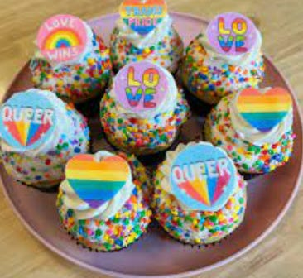](https://substackcdn.com/image/fetch/f_auto,q_auto:good,fl_progressive:steep/https:/substack-post-media.s3.amazonaws.com/public/images/427f12b6-b8ff-4ec7-96d8-0d8aee1d27c5_366x336.png)](https://substackcdn.com/image/fetch/f_auto,q_auto:good,fl_progressive:steep/https%3A%2F%2Fsubstack-post-media.s3.amazonaws.com%2Fpublic%2Fimages%2F427f12b6-b8ff-4ec7-96d8-0d8aee1d27c5_366x336.png" \t "_blank)

Cult behavior is interesting, and weaponized cult behavior can be extremely powerful. I believe that in the age of the internet and podcasts, there is a new type or form of cult developing. That is, cults can now be digitally based, and are wave-like in nature. With many converts joining almost simultaneously. Crowdstalking or gangstalking provides one example of this, and is currently being actively promoted and exploited by CDC subcontractors to harass those who speak in opposition to government-approved COVID narratives.

It is unclear to me how much of this new type of cult is driven by a strong leader, like Fauci or in the youth transgender movement, influencers like Elliot Page. Are the definitions for what is and isn’t a cult changing? Are government and corporate interests driving people into a cult-like mentality? How can we protect ourselves, friends and our loved ones from being seduced by these cults?

In the case of the girl-trans cults, some parents have had success by pulling their girls out of school, removing the internet (social media) from their daughter’s lives and taking back control. Basically, cutting off all media, advertising and contact with others in the cult.

But what about for adults exhibiting cult-like behaviors? For instance, people who will insist on getting multiply boosted or wearing masks to the work-place, etc. Or even those, who just can’t stand criticism of Anthony Fauci or climate change cult leaders?

How do we teach resistance to cult formation and behaviors, particularly as they seem so insidiously pervasive in our digital lives?

*“Who is Robert Malone” is a reader supported Substack publication. Please consider subscribing.*

*Subscribed*

[Give a gift subscription](https://rwmalonemd.substack.com/subscribe?&gift=true)

Thank you for reading Who is Robert Malone. This post is public so feel free to share it.

[Share](https://rwmalonemd.substack.com/p/promoting-a-cult-for-the-good-of?utm_source=substack&utm_medium=email&utm_content=share&action=share&token=eyJ1c2VyX2lkIjoyMjk3ODczNiwicG9zdF9pZCI6MTM3MTQ5OTIzLCJpYXQiOjE2OTUwNjc2MjcsImV4cCI6MTY5NzY1OTYyNywiaXNzIjoicHViLTU4MzIwMCIsInN1YiI6InBvc3QtcmVhY3Rpb24ifQ.ui0G8ClgTU7Rzv1YD2AJRou61rHFc8iKrEb8oGxuN8Y)

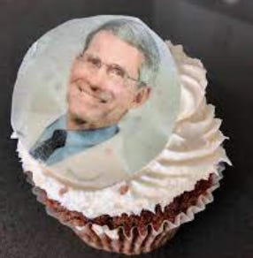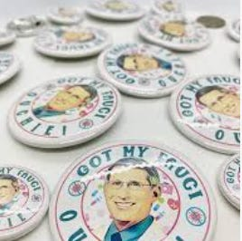

[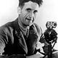](https://substack.com/profile/51190734-simulationcommander?utm_source=post-reactions-face)

[](https://substack.com/profile/163683262-kumquatknight?utm_source=post-reactions-face)

[https://substackcdn.com/image/fetch/w_80,c_limit,f_auto,q_auto:good,fl_progressive:steep/https%3A%2F%2Fbucketeer-e05bbc84-baa3-437e-9518-adb32be77984.s3.amazonaws.com%2Fpublic%2Fimages%2Fb65949e6-fb30-400a-87ac-ca16161176f4_394x296.jpeg](https://substack.com/profile/59568709-summer?utm_source=post-reactions-face)

[](https://substack.com/profile/83482704-sheldon-h?utm_source=post-reactions-face)

[](https://substack.com/profile/20954755-natasha-devine?utm_source=post-reactions-face)

63 Likes

·

[3 Restacks](https://substack.com/note/p-137149923/restacks?utm_source=substack&utm_content=facepile-restacks)

63

[6](https://rwmalonemd.substack.com/p/promoting-a-cult-for-the-good-of/comments)

3

[Share](javascript:void(0))

<https://rwmalonemd.substack.com/p/promoting-a-cult-for-the-good-of?utm_campaign=email-post&r=doii8&utm_source=substack&utm_medium=email>

**6 Comments**

Top of Form





Bottom of Form

|  |  |
| --- | --- |
| [[https://substackcdn.com/image/fetch/w_66,h_66,c_fill,f_auto,q_auto:good,fl_progressive:steep/https%3A%2F%2Fsubstack.com%2Fimg%2Favatars%2Flogged-out.png](https://substack.com/profile/51190734-simulationcommander)](https://substack.com/profile/51190734-simulationcommander) | **[SimulationCommander](https://substack.com/profile/51190734-simulationcommander)**  [Writes Screaming into the Void](https://simulationcommander.substack.com/?utm_source=substack&utm_medium=web&utm_content=comment_metadata)  [19 mins ago](https://rwmalonemd.substack.com/p/promoting-a-cult-for-the-good-of/comment/40292379)·*edited 14 mins ago***Liked by Robert W Malone MD, MS**  Great article, and if you don't mind I'll provide a recent example I've come across:  <https://www.politico.com/news/2023/09/15/poll-covid-booster-democrats-00116123>  "About 3 in 5 voters plan to get the new Covid booster"  This is how they try to convince you that doing what they want puts you in the majority (sometimes they come out and say "on the right side"). "We're all doing this thing, so you should do it, too!"  I'm old enough to remember when peer pressure was bad -- now government uses it against us.  [LIKE (9)](javascript:void(0))  REPLY  SHARE |

[**3 replies by Robert W Malone MD, MS and others**](https://rwmalonemd.substack.com/p/promoting-a-cult-for-the-good-of/comment/40292379)

|  |  |
| --- | --- |
| [[https://substackcdn.com/image/fetch/w_66,h_66,c_fill,f_auto,q_auto:good,fl_progressive:steep/https%3A%2F%2Fsubstack-post-media.s3.amazonaws.com%2Fpublic%2Fimages%2F41c00131-2ea6-47af-8af3-1155b091a5ad_96x96.png](https://substack.com/profile/61494942-tritorch)](https://substack.com/profile/61494942-tritorch) | **[TriTorch](https://substack.com/profile/61494942-tritorch)**  [Writes Out Here On the Perimeter](https://tritorch.substack.com/?utm_source=substack&utm_medium=web&utm_content=comment_metadata)  [15 mins ago](https://rwmalonemd.substack.com/p/promoting-a-cult-for-the-good-of/comment/40292642)**Liked by Robert W Malone MD, MS**  Dr. Molone, here is another example of this madness. Result of Relentless Vaccine Propaganda: Exhibit B - Dr. Fauci Bring Us Vaccines (sung by a young teen to the tune of Mr. Sandman): <https://bitchute.com/video/xKfZOGQoLc3z> [55seconds]  [LIKE (2)](javascript:void(0))  REPLY  SHARE |

[**4 more comments...**](https://rwmalonemd.substack.com/p/promoting-a-cult-for-the-good-of/comments)

**9 Comments**

Share

Top of Form





Bottom of Form

Top First

|  |  |
| --- | --- |
| [[https://substackcdn.com/image/fetch/w_66,h_66,c_fill,f_auto,q_auto:good,fl_progressive:steep/https%3A%2F%2Fsubstack.com%2Fimg%2Favatars%2Flogged-out.png](https://substack.com/profile/51190734-simulationcommander)](https://substack.com/profile/51190734-simulationcommander) | **[SimulationCommander](https://substack.com/profile/51190734-simulationcommander)**  [Writes Screaming into the Void](https://simulationcommander.substack.com/?utm_source=substack&utm_medium=web&utm_content=comment_metadata)  [21 mins ago](https://rwmalonemd.substack.com/p/promoting-a-cult-for-the-good-of/comment/40292379)·*edited 16 mins ago***Liked by Robert W Malone MD, MS**  Great article, and if you don't mind I'll provide a recent example I've come across:  <https://www.politico.com/news/2023/09/15/poll-covid-booster-democrats-00116123>  "About 3 in 5 voters plan to get the new Covid booster"  This is how they try to convince you that doing what they want puts you in the majority (sometimes they come out and say "on the right side"). "We're all doing this thing, so you should do it, too!"  I'm old enough to remember when peer pressure was bad -- now government uses it against us.  [LIKE (15)](javascript:void(0))  REPLY (1)  SHARE |

|  |  |
| --- | --- |
| [[author](https://substack.com/profile/49176289-robert-w-malone-md-ms)](https://substack.com/profile/49176289-robert-w-malone-md-ms) | **[Robert W Malone MD, MS](https://substack.com/profile/49176289-robert-w-malone-md-ms)**  [20 mins ago](https://rwmalonemd.substack.com/p/promoting-a-cult-for-the-good-of/comment/40292432)**Author**  perfect example  [LIKE (5)](javascript:void(0))  REPLY (1)  SHARE |

|  |  |
| --- | --- |
| [[https://substackcdn.com/image/fetch/w_66,h_66,c_fill,f_auto,q_auto:good,fl_progressive:steep/https%3A%2F%2Fsubstack.com%2Fimg%2Favatars%2Flogged-out.png](https://substack.com/profile/51190734-simulationcommander)](https://substack.com/profile/51190734-simulationcommander) | **[SimulationCommander](https://substack.com/profile/51190734-simulationcommander)**  [Writes Screaming into the Void](https://simulationcommander.substack.com/?utm_source=substack&utm_medium=web&utm_content=comment_metadata)  [18 mins ago](https://rwmalonemd.substack.com/p/promoting-a-cult-for-the-good-of/comment/40292575)  There's simply no way that I believe that 60% of "voters" are planning on getting a booster. Before they yanked the stats, booster uptake was something like 15% -- and every 'new' booster that comes out makes the 'anti-vaxxers' look more and more sane when we said that they'd never be fully vaccinated.  [LIKE (8)](javascript:void(0))  REPLY (1)  SHARE |

|  |  |
| --- | --- |
| [[https://substackcdn.com/image/fetch/w_66,h_66,c_fill,f_auto,q_auto:good,fl_progressive:steep/https%3A%2F%2Fsubstack.com%2Fimg%2Favatars%2Flogged-out.png](https://substack.com/profile/61494942-tritorch)](https://substack.com/profile/61494942-tritorch) | **[TriTorch](https://substack.com/profile/61494942-tritorch)**  [Writes Out Here On the Perimeter](https://tritorch.substack.com/?utm_source=substack&utm_medium=web&utm_content=comment_metadata)  [9 mins ago](https://rwmalonemd.substack.com/p/promoting-a-cult-for-the-good-of/comment/40293042)  They aren't real numbers. Just like the artificial political polls these are used to sway the perception and opinion of the public. Fear of missing out (FOMO) works extremely well on those without a solidly defined sense of self. These types look for bandwagons to join because they do not know what they stand for and so they adopt a position from the crowd. NPC is a adequate term to describe them.  The following are lessons they never bothered to learn:  It’s better to walk alone than with a crowd going in the wrong direction. —Gandhi  **Fear has two meanings - Forget Everything And Run or Face Everything And Rise. The choice is yours. —Proverb**  They laugh at me because I'm different. I laugh at them because they're all the same. —Cobain  [LIKE (3)](javascript:void(0))  REPLY  SHARE |
| [[https://substackcdn.com/image/fetch/w_66,h_66,c_fill,f_auto,q_auto:good,fl_progressive:steep/https%3A%2F%2Fsubstack.com%2Fimg%2Favatars%2Flogged-out.png](https://substack.com/profile/61494942-tritorch)](https://substack.com/profile/61494942-tritorch) | **[TriTorch](https://substack.com/profile/61494942-tritorch)**  [Writes Out Here On the Perimeter](https://tritorch.substack.com/?utm_source=substack&utm_medium=web&utm_content=comment_metadata)  [17 mins ago](https://rwmalonemd.substack.com/p/promoting-a-cult-for-the-good-of/comment/40292642)**Liked by Robert W Malone MD, MS**  Dr. Molone, here is another example of this madness. Result of Relentless Vaccine Propaganda: Exhibit B - Dr. Fauci Bring Us Vaccines (sung by a young teen to the tune of Mr. Sandman): <https://bitchute.com/video/xKfZOGQoLc3z> [55seconds]  [LIKE (4)](javascript:void(0))  REPLY  SHARE |

|  |  |
| --- | --- |
| [[https://substackcdn.com/image/fetch/w_66,h_66,c_fill,f_auto,q_auto:good,fl_progressive:steep/https%3A%2F%2Fsubstack.com%2Fimg%2Favatars%2Flogged-out.png](https://substack.com/profile/13309582-brad)](https://substack.com/profile/13309582-brad) | **[Brad](https://substack.com/profile/13309582-brad)**  [Writes Euphoric Recall](https://www.euphoricrecall.net/?utm_source=substack&utm_medium=web&utm_content=comment_metadata)  [17 mins ago](https://rwmalonemd.substack.com/p/promoting-a-cult-for-the-good-of/comment/40292619)  The covid cult is 100% a real thing, and the pandemic was a textbook example of mass formation psychosis. That's the only way to explain why, even after it became indisputable that many, if not most, of our public health decisions had no basis in real science, hundreds of millions of people acquiesced to a pathologized-totalitarian science experiment with no off-ramp justified with constantly shifting and contradictory criteria and the calculus of the most risk-averse individuals.  <https://www.euphoricrecall.net/p/covid-as-mass-formation-psychosis>  [LIKE (3)](javascript:void(0))  REPLY  SHARE |
| [[https://substackcdn.com/image/fetch/w_66,h_66,c_fill,f_auto,q_auto:good,fl_progressive:steep/https%3A%2F%2Fsubstack.com%2Fimg%2Favatars%2Flogged-out.png](https://substack.com/profile/75257813-baltimoracle)](https://substack.com/profile/75257813-baltimoracle) | **[Baltimoracle](https://substack.com/profile/75257813-baltimoracle)**  [Writes If you don't think this is Funn…](https://baltimoracle.substack.com/?utm_source=substack&utm_medium=web&utm_content=comment_metadata)  [1 min ago](https://rwmalonemd.substack.com/p/promoting-a-cult-for-the-good-of/comment/40293398)  In the cult of " scientism", our spirit, the imprint in each of us that is clearly a reflection of our Creator, cannot be quantified, and is therefore valueless, and can be extinguished without penalty .... bringing forth transhumanism  [LIKE](javascript:void(0))  REPLY  SHARE |

|  |  |
| --- | --- |
| [[https://substackcdn.com/image/fetch/w_66,h_66,c_fill,f_auto,q_auto:good,fl_progressive:steep/https%3A%2F%2Fsubstack.com%2Fimg%2Favatars%2Flogged-out.png](https://substack.com/profile/111733953-cindy)](https://substack.com/profile/111733953-cindy) | **[Cindy](https://substack.com/profile/111733953-cindy)**  [3 mins ago](https://rwmalonemd.substack.com/p/promoting-a-cult-for-the-good-of/comment/40293321)  Fear was at the core of the Covid vaccine cult--we were terrorized into believing that if we didn't get the jabs we would die of Covid, and since there was no way to avoid being infected, the choice was jabs or death.  We can't convince cult members to quit. They have to decide that for themselves. But what we can do is create alternatives, ways of thinking and living that are more attractive than the cult of fear. Already people are refusing to get boosted, which is very, very good, but they still need alternatives.  With the economic disaster that's looming, whether from a gov't shutdown, more banks collapsing, or the middle class going completely belly up--probably some combination if not all three--people are going to need alternatives. As we saw in the 1930's, the Great Depression drove a lot of people to fascism because they saw it as the only way to survive.  We need to provide other choices and use the media we have to discuss them. Charles Hugh Smith offers an alternative way of thinking in this article on [dailyreckoning.com](http://dailyreckoning.com/): <https://dailyreckoning.com/reinventing-democracy/>. Once again, I read some of the writers on DR but avoid others.  Let's keep the conversation going. Dr. Malone's articles are always thought-provoking, and the comments certainly offer a spectrum of ideas.  Thank you, Drs. Malone, for giving us this forum.  [LIKE](javascript:void(0))  REPLY  SHARE |
| [[https://substackcdn.com/image/fetch/w_66,h_66,c_fill,f_auto,q_auto:good,fl_progressive:steep/https%3A%2F%2Fsubstack-post-media.s3.amazonaws.com%2Fpublic%2Fimages%2Fd51d759a-6838-4907-9f03-d64b3977c676_836x632.jpeg](https://substack.com/profile/61361018-guido-vandeven)](https://substack.com/profile/61361018-guido-vandeven) | **[Guido VANDEVEN](https://substack.com/profile/61361018-guido-vandeven)**  [4 mins ago](https://rwmalonemd.substack.com/p/promoting-a-cult-for-the-good-of/comment/40293242)  Great Dr. Malone, In every cult there’s a moment when they start eating their own children, time is against them.  [LIKE](javascript:void(0))  REPLY  SHARE |